Name : Puna Poudel

Assignment: module 1.2

Professor: Chandra

Due date: 02/06/2024

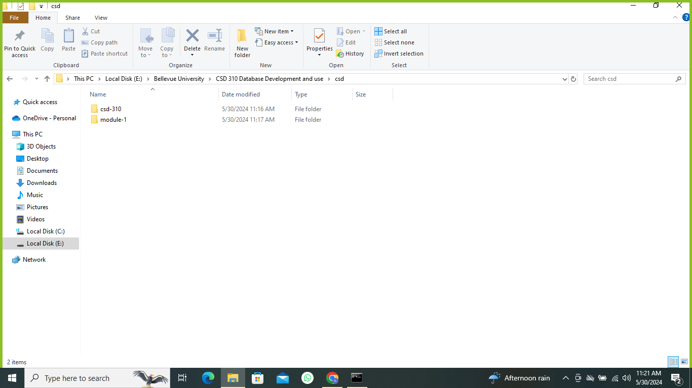

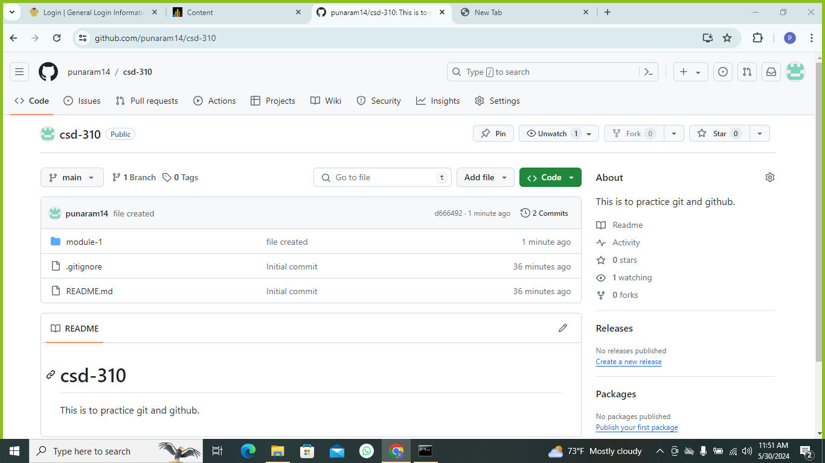

Github link: <https://github.com/punaram14/csd-310.git>

